Table of Contents
Document Identification 1
Copyright Statement 1
Container Sub-system 2
Box 2
Lid 3
Alignment Plate 4
Retainer 4
Constants File 4
Fasteners 5

Document Identification
This document describes the Lock Controller container sub-system.
Document configuration information is in the footer of each page.

Copyright Statement
A copyright statement is attached to every file and product created by the SoftKnit21 project. It takes the form of the copyright statement for this document:
This project provides a modern way to design and knit garments using Passap E6000 knitting machines. This document describes the container for the Lock Controller system which reports on, and controls, the operation of a Lock Controller.
Copyright (C) 2020 Owen Mace and Odile Lambert.
This document is free information: you can redistribute it and/or modify it under the terms of the GNU General Public License as published by the Free Software Foundation, either version 3 of the License, or (at your option) any later version.
This program is distributed in the hope that it will be useful, but WITHOUT ANY WARRANTY; without even the implied warranty of MERCHANTABILITY or FITNESS FOR A PARTICULAR PURPOSE. See the GNU General Public License for more details.
You should have received a copy of the GNU General Public License along with this program. If not, see <https://www.gnu.org/licenses/>.

Container Sub-system
The Container houses the Lock Controller electronics and attaches to the E6000.
The Container sub-system consists of five components:
- A Box in which the electronics are mounted,
- A Lid to cover the Box,
- An Alignment Plate to ensure that the Container remains upright,
- A Retainer to hold the Container in place on the upper rear rail of the E6000 stand, and
- Fasteners.
The 3D design tool used is openSCAD, an open source tool that uses a C-like language to describe models, compile, display and write output files suitable for manufacture. A common, include file holds dimensions and constants common to all printed components.
Each component is now described briefly.

Box
The Box is illustrated:
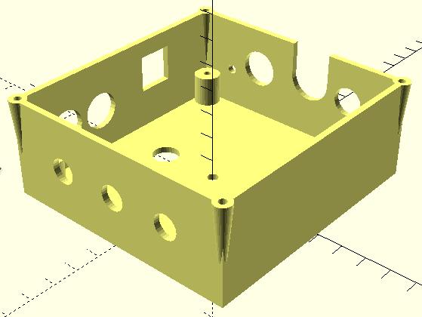
The features of the Box are:
- Four posts inside the box on which the PCB is mounted and screwed down.
- Four cones on the top of the box onto which the Lid is screwed.
- Three ventilation holes at the bottom of the box when mounted on the E6000 rail.
- Openings at the far end for (from the left):
  - A small hole through which to view the orange indicator LED,
  - A hole for the USB cable that plugs into the Arduino Nano,
  - A large hole and slot the six pin DIN connector that plugs into the E6000 Console,
  - A hole for the +15V barrel jack, and
  - A small hole (obscured in this image) through which to view the red +15V LED,
- Along the left side of the box are:
  - A square hole for the RJ45 cable that controls the 4600 motor, and
  - Two holes for audio plugs for the E3000A motor. They are labelled ‘A’ and ‘C’ to correspond with the socket markings on the back of the E3000A motor box,
- Two large holes in the bottom of the box (one is obscured) for matching pegs in the Alignment Plate.
- Single small hole in the bottom of the Box for an M3 bolt.
The box is described in a file named Box.scad.

Lid
The Lid matches the top of the Box.
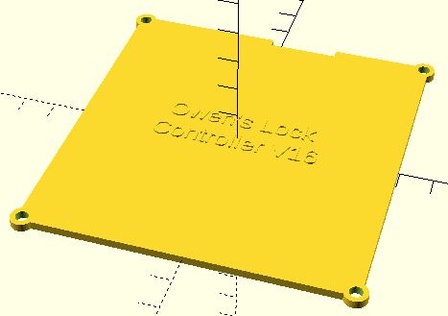
The lid is described in a file named Lid.scad.

Alignment Plate
The Alignment Plate is illustrated:
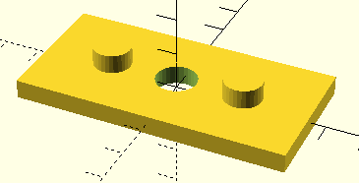
The two pegs fit into matching holes in the bottom of the Box and the M4 bolt passes through the centre hole.
The alignment plate is described in a file named Alignment Plate.scad.

Retainer
The Retainer is illustrated:
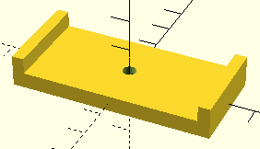
The M4 bolt passes though the centre hole and there is a socket for the nut on the other side. The two raised ends prevent the Retainer turning behind the C section of the E6000 rear rail.
The retainer is described in a file named Retainer.scad.

Constants File
All constants required for the four models above are located in a common include file called LC_Constants.scad.

Fasteners
The following hardware is required:
- An M3 x 35 (or M3 x 40) Phillips head bolt and nut pass through the box, Alignment Plate and Retainer to fasten the Container to the E6000 upper rear rail, and
- Eight 4g x ½” (or M2 x 1cm) screws are used to attach the PCB and to the Box. Soft iron screws are preferred (to, for example, stainless steel) so that a magnetised screw driver can pick up the screws.
Phillips head fasteners are preferred.

